.

**DOCUMENT UNIVERSE**

**FOR KERA**

**CORPORATION DETAILS**

Date : February 18th 2017

Version : 1.3

Written by : Phéçale LAFIA

**UESHIN SECURITY**

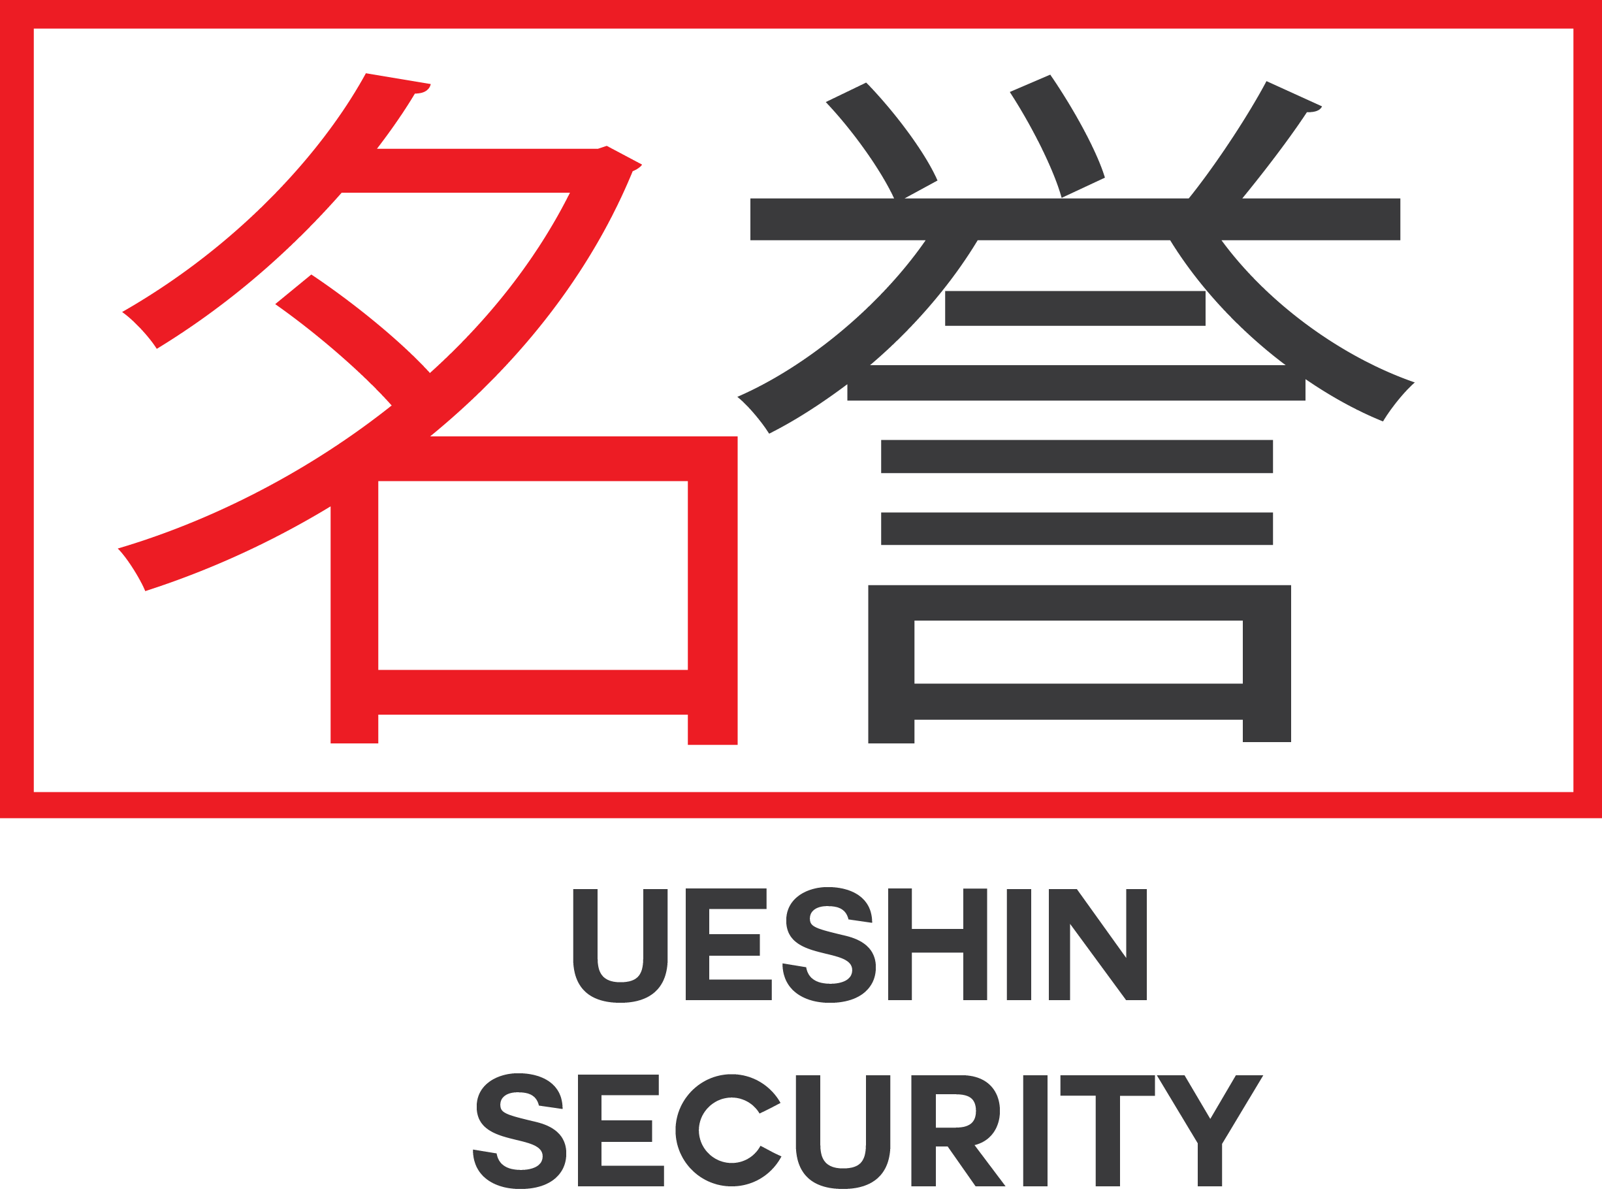

Domain: Personal security, escort, and everything related to security.

Description: Ueshin Security is a large militarized corporation specializing in securing people and property. This corporation is present in the confines of the five known systems and tirelessly struggles to ensure that these customers can live and move without problems.

The owner board is a grouping of five brothers descendants of samurai who have brought their ancestral codes back into this futuristic world. They grew up with these codes that have anchored in them. But in a world as ruthless as the one in which they live, they preferred to get rid of the samurai code and they established their laws, the most important of which is "the moment you pay, we save your ass. "

The five Ueshin brothers focused on customer safety and loyalty. What is special about this corporation is their open-mindedness. Ueshin refuses anyone to join the family. Brigand, mercenary, outlaw, doctor, diplomat ... provided once in the family, they understand the rules and they change. Those who once violated the sacred rule and disgraced the clients were executed by **Muri Asan Ueshin**, the eldest brother, the most feared of the Ueshin brothers.

Even though the corporation is accused of being a great concealed supporter of militias of assassination, illegal mercenaries, and outlaws, the brothers take every opportunity to remind themselves of their mission: Protect those who have the means and that they will not derogate under any pretext from this rule. They do not hesitate to show that they are against Astra politics and constantly call Freeg Fausty a disaster for the human race. Freeg, on the other hand, treats them as brigands without faith or law. And he does not forget to specify that he will have time to personally take care to erase them from the memory of all people living in the five homologated systems.

In the past and until now, they are constantly having tensions between Ueshin and Astra. And it will continue for a long time.